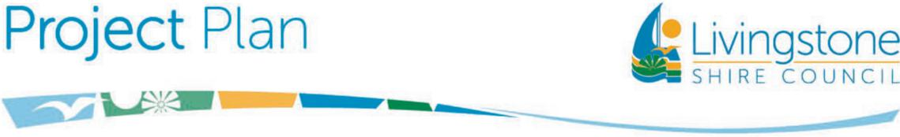

**Yeppoon Landfill Cell 3**

**Project Description:** The project aims to construct a new Cell at Yeppoon Landfill, adjacent to the existing Cell 2. The new Cell 3 covers 18,200m2 of floor area and will provide an additional 180,000m3 of airspace once completed, expecting to extend the life of Yeppoon Landfill until at least 2040.

Council received grant funding from the Works 4 Queensland Program of $4.18M towards the total project budget of $6.6M.

The Construction Contract has been awarded to Calibre Earthmoving and Environmental Pty Ltd.

**Reasons for Project:** The existing Cell 2 is expected to be full in 2027 at the current rates, and further space is required as part of Council’s Forward Operating Plan.

**Benefits of Project:** Continued landfill operations and sustainability of service to the community.

**Estimated Total Cost:** $5.5M (Construction Contract)   
**Commencement Date:**  November 2024 (Construction)

**Duration of Project:** Twelve (12) months

**Contact Officer:** Daniel Stroud, Project Manager

**Public Consultation:** None

**Potential Interruptions:** Minimal impact on users of Yeppoon Landfill

Potential wet weather delays for construction contractor, unfavourable latent site conditions

