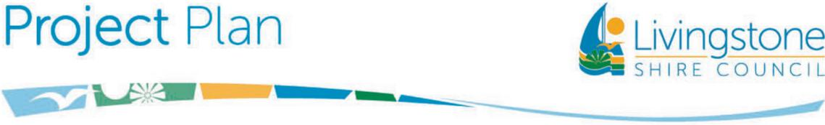

**Taroomball Trunk Sewer Infrastructure Upgrade**

**Project Description:** The Project consists of delivering the essential trunk sewer infrastructure to service the Priority Infrastructure Areas within Tanby and Taroomball catchments. Essentially, the Project involves construction of the new Tanby Road Sewer Pump Station (SPS), Gravity and Rising mains, decommissioning of existing Tanby Road SPS, and Upgrading of Carige Boulevard SPS.

The Council has received 60% subsidy through Local Government Grants and Subsidies Program (LGGSP- 2024-28).

The Contract has been awarded to Utlistra Pty Ltd.

**Reasons for Project:** Delivery of this critical Infrastructure is instrumental in alleviating current sewer capacity issues and meeting future sewer demand within the Priority Infrastructure Area for the next 30 years.

**Benefits of Project:** Ability to meet the growing housing demand by opening potential developments within Tanby and Taroomball catchments. Improved functional life of assets and improved level of services.​ Compliance with Council’s LGIP and Water Supply (Safety and Reliability) Act.

**Estimated Total Cost:** ~$6.78 Million (Construction)   
**Commencement Date:** March 2025

**Duration of Project:** ~Twelve (12) months

**Contact Officer:** Arvind Singh, Manager Infrastructure Projects

**Public Consultation:** Minimal – public awareness only – via Council Website, Council Facebook page, media publicity

**Potential Interruptions:** Minimal impact on residents

Potential traffic delays on Yeppoon Road, Tanby Road, and Taranganba Road corridors during the construction works.

